What's New This Sprint

You have run a sprint before, so this is the short version: everything that is different this time, in one place. You must read through this document before starting the sprint.

⚠️You must install Docker
All model runs now happen inside Docker containers. Download and install Docker before you pick up a task — if it is missing, the init script will block you and tell you to install it. Verify you can build and run a docker image in your environment before proceeding.

On Windows, WSL is required. Install Windows Subsystem for Linux, run Docker with the WSL 2 backend, and work from inside WSL rather than PowerShell or Command Prompt. We are not able to support setups that skip it — if something breaks outside WSL, we will generally not be able to help you fix it. If WSL is new to your machine, or your laptop is managed and might block it, sort that out now rather than on sprint day.

Why: with both agents running directly on your machine, they could interfere with each other — conflicting servers and ports, one agent killing a process the other had started. Containers isolate each run.

Aside from having Docker installed, setup and execution should feel the same as before.

Tooling changes

1. Tasks are now assigned to you by Woz, a Slack bot

You no longer claim a task from the Studio dashboard.

- When a sprint opens, Woz messages you in Slack and asks whether you want a task.
- You accept, and Woz sets the task up for you in Studio.
- When you submit that task in Studio, you can be assigned another one.

A few things to know about how it behaves:

- Woz is not conversational. It is not Maven — you cannot ask it questions or request a specific task. You interact with it only through the buttons it shows you.
- If Woz asks whether you still want to continue a task and you answer no, the task goes back and is reassigned to someone else.
- A claimed task with no activity for three hours is automatically reassigned.

2. You will usually not run a task you wrote

Tasks come from a curated set of accepted pre-work tasks, and Woz assigns them based on your background and on where the sprint currently has a need. This is a change from what was communicated in previous weeks.

You will generally be matched to the domain you have written in — if your pre-work was backend, expect backend; if it was DevOps, expect DevOps. Pre-work is still where tasks are authored, and it is still paid separately.

3. One task at a time

Running multiple tasks in parallel is not supported. Quality is paramount. Finish and submit the task you were assigned before taking another.

4. New field in Studio: self-reported time

You will report how long the task took you — both the model runs and the feedback. This is metadata only. It does not affect your compensation or whether the task is accepted.

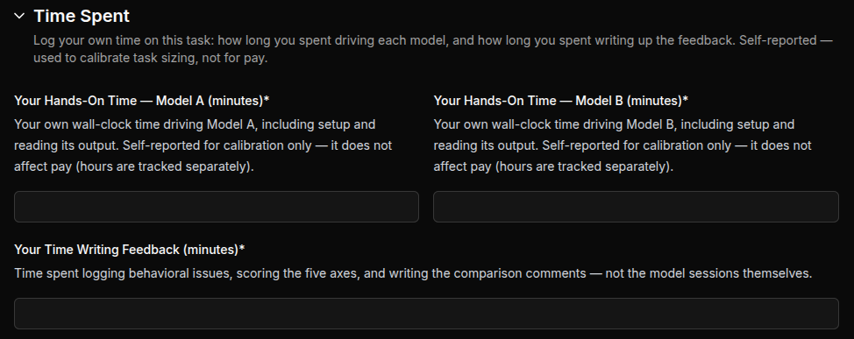

5. New field in Studio: Communication Quality

Grade how well the models communicated to you based on the following rubric:
1 = Cannot be understood at all
2 = Hard to follow; wrong words, jargon, or messy structure
3 = Understandable with effort; vague or wordy in places
4 = Clear on first read; minor wording or length issues
5 = Clear, exact, and to the point

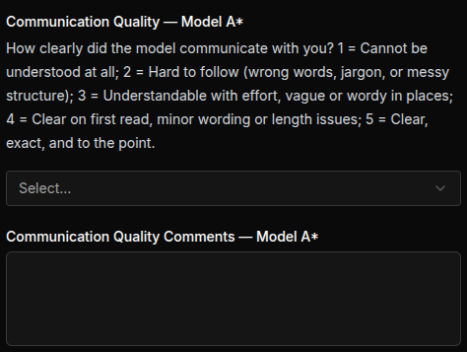

Guidance changes

6. Behavioral issues: accuracy over volume

Flagging behavioral issues is still one of the most valuable things you produce, and you should keep actively watching for them. What changed is that there is no minimum you have to hit. A fixed threshold puts pressure on the count rather than on the observation, and flags lose their value to the client as soon as they get noisy.

Accuracy comes first, volume second. Flag everything you genuinely observe, and nothing you do not. Note: We monitor the quality and quantity of flags. Multiple submissions with 0 flags will get flagged for Quality audits.

7. Rate what you saw, in both directions

Under the old setup, you ran a task you had authored, and the ratings carried a second job: showing the task was hard enough. That is no longer the case. Task difficulty is settled in pre-work, reviewers no longer audit it, instead auditing the accuracy and quality of your feedback.

So the rating only has one job now — reflecting what the agents actually did. Be accurate: Score high where a model earned it and low where it did not. Ensure the written feedback supports the rating.

This does not mean going easy on the models. The task being difficult on paper is not the same as the run being demanding: keep pushing both agents to their limits, follow up, and put real pressure on the solution before you judge it. The difficulty is what surfaces the behavior worth reporting. Your job is to draw it out and rate it honestly.

8. Time to resolution: clarified definition

It is your judgment of which side reached a working solution sooner, measured in agent working time. If one session sat idle while you were busy with the other, that idle time does not count against it. Judge it from the agent’s point of view, not the wall clock.

9. Both sessions start from the exact same opening prompt

The opening prompt is automatically injected into Claude Code once you start ./claude-dev. This is normal and expected. Don’t interrupt it.

10. Do not hand the agent your success criteria

The success criteria you are grading against stay out of the session, in full and in part. A few submissions last sprint pasted the checklist straight into the prompt. This circumvents what the comparison is meant to measure, which is whether the model can get there without being told.

11. Do not present the high-level task goal directly

Do not state the goal outright and ask the model to satisfy it. Prompt it as a real user would and work toward that goal through the session. What is being measured is how the model gets there, not how well it executes a specification you handed it.

In short

- Install Docker before you start. On Windows, WSL too.
- Wait for Woz in Slack; do not go looking for a task in the dashboard.
- Expect a task you did not write.
- One at a time.
- Flag accurately rather than abundantly, and rate honestly rather than harshly.

